 | Preliminary Estimates of the Impact of Hurricane Ida to the Louisiana Timber Industry  Developed by Jinggang Guo and Sun Joseph Chang  In conjunction with LDAF and U.S. Forest Service

Staff Report No. 2021-63

Introduction

Hurricane Ida made landfall in Louisiana on Sunday, August 29, 2021, as a category 4 hurricane before moving over the Northeast, exactly 16 years after Katrina hit Louisiana. Even though Hurricane Ida weakened considerably after it made landfall, it nevertheless, brought damaging wind and torrential rains as it moved inland. In addition to storm surge along the coastal areas, it seriously damaged large areas of forests in Southeastern Louisiana.

The Louisiana Department of Agriculture and Forestry (LDAF) soon arranged a flyover across parishes hard hit by the storm to get an aerial view of the damage (Figure 1). Damage to the forest resources was widespread and extensive. LSU AgCenter personnel collaborated with the LDAF and USDA Forest Service to develop estimates of the economic impacts of damaged timber. Estimated loss values for each species were based on the area affected (acres) together with average inventory per acre from Forest Inventory and Analysis Database. The rest of this report includes a brief description of the methodology used to evaluate the economic damage and a summary of the total estimated impact.

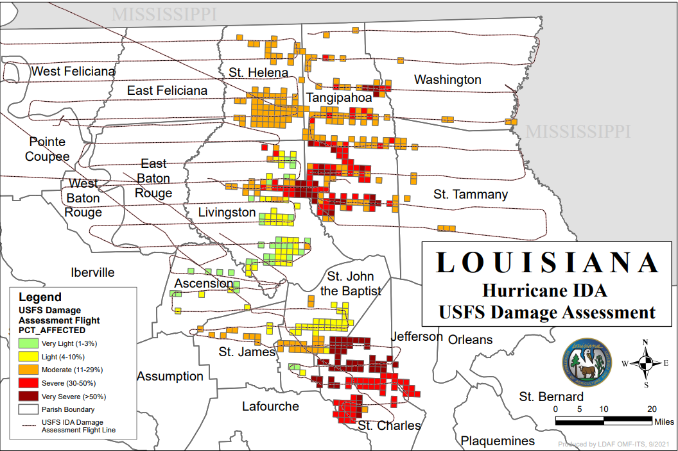
Figure 1 Aerial view of the damaged area caused by Hurricane Ida

Methodology

Personnel with the Louisiana Department of Agriculture and Forestry conducted flyovers along the path of Hurricane Ida to assess the damage to the forest area. Standard procedures and protocols were utilized in conducting this assessment which divides impacted areas into smaller grid cells (approximately 910 acres) with very light, light, moderate, severe, and very severe damages. Each designation (very light, light, moderate, severe, and very severe) corresponds to a certain percentage of tree stems damaged in that cell. LSU AgCenter personnel then took these impacted cells and adjusted the acreage by their corresponding designation to develop parish-based estimates of the number of acres of timber impacted that were listed in Table 1.

Step 2 is to collect data from the USDA Forest Service Forestry Inventory and Analysis system to determine a parish-based estimate of timber inventory by tree diameter sizes and by two major categories (pine and hardwood). Data within these two categories were further broken down into three separate classifications, sawtimber, chip-n-saw, and pulpwood. While data for pine timber was separated into those three classifications, data for hardwood timber was only separated into two categories, sawtimber and pulpwood. This analysis resulted in per acre estimates of the total volume of timber in each of the five classifications: Pine-Sawtimber, Pine-Chip-n-Saw, Pine-Pulpwood, Hardwood-Sawtimber, Hardwood Pulpwood. These per acre estimates were then multiplied by the estimates of number of acres impacted to obtain a total volume of each classification impacted by parish, which were then converted to units of measure that align with traditional market and price units (i.e., $/MBF for sawlog, $/cord for pulpwood and Chip-n-Saw).

The next step was to determine what was salvageable from the damaged areas. The ability to salvage downed timber hinges on several factors. First, there is a short window that downed timber must be salvaged before disease and other quality impacts essentially makes the timber un-marketable. Also, typically when a weather event such as this occurs, the amount of timber that becomes available to the market can overwhelm the market impacting both the prices received as well as the ability to sell timber. Salvage rates from two previous hurricanes Laura and Delta fall within 1-2%. Considering the recent weather conditions, we chose a 1 percent salvage rate to estimate the economic impacts of the physical damage except for Hardwood-Sawtimber. Given the limited market that currently exists for hardwood pulpwood, it was assumed that the market would not be able to support any salvaged sawtimber sized timber in addition to the other timber already feeding that market. As such, it was assumed that none of the Hardwood-Sawtimber would be salvageable. Assumptions regarding market prices were set based on the most recent report of the Louisiana Department of Agriculture and Forestry’s Quarterly Report of Forest Products (second quarter of 2021).

Results

Table 1 presents estimates of the number of acres of timber impacted along with the volume of timber damaged for selected parishes. Hurricane Ida caused severe damage to 167,622 acres of forestland in 11 parishes in Louisiana, including 57,611 acres in the very severe category (50%+ damaged) and 47,402 acres in the severe category (30-50% damaged). This represents roughly 1 percent of the total 15 million acres of forest land estimated by the USDA Forest Service. Combining inventory and GIS data to map the volume damage, we found that an estimated 181 million cubic feet (ft³) of timber were affected, with 86 million ft³ of pine timber and 95 million ft³ of hardwood timber. The highest timber volume losses were in the southeast Louisiana parish of Tangipahoa (88 million ft³), followed by Livingston parish (33 million ft³).

Table 1. Estimated Area Impacted and Volumes of Timber Damaged, by Parish
Parishes With Impacted Timber | Estimated Acres of Timber Impacted | Volume of  Pine - Sawtimber Damaged  (Cubic Feet) | Volume of  Pine -  Chip-n-Saw Damaged  (Cubic Feet) | Volume of  Pine - Pulpwood Damaged  (Cubic Feet) | Total Volume of Pine Timber Damaged  (Cubic Feet) | Volume of Hardwood - Sawtimber Damaged  (Cubic Feet) | Volume of Hardwood -  Pulpwood  Damaged  (Cubic Feet) | Total  Volume of Hardwood Timber Damaged  (Cubic Feet) | Total  Volume of All Timber Damaged  (Cubic Feet)
Ascension | 614 |  |  |  |  | 98,290 | 158,425 | 256,715 | 256,715
Jefferson | 4,456 |  |  |  |  | 200,935 | 171,698 | 372,633 | 372,633
Lafourche | 382 |  |  |  |  |  | 6,496 | 6,496 | 6,496
Livingston | 16,479 | 9,784,169 | 6,408,635 | 2,641,032 | 18,833,837 | 7,208,902 | 6,667,727 | 13,876,629 | 32,710,466
St. Charles | 45,648 |  |  |  |  | 8,010,209 | 12,964,076 | 20,974,284 | 20,974,284
St. Helena | 18,789 | 4,796,987 | 4,345,501 | 3,800,147 | 12,942,635 | 2,913,402 | 4,947,176 | 7,860,578 | 20,803,213
St. James | 2,444 |  |  |  |  | 1,302,719 | 2,270,758 | 3,573,477 | 3,573,477
St. John | 10,514 |  |  |  |  | 4,248,139 | 6,003,557 | 10,251,695 | 10,251,695
St. Tammany | 2,880 | 1,648,562 | 482,711 | 431,712 | 2,562,985 |  |  |  | 2,562,985
Tangipahoa | 63,415 | 21,238,313 | 19,527,808 | 9,999,741 | 50,765,861 | 15,781,576 | 21,941,067 | 37,722,643 | 88,488,505
Washington | 2,000 | 179,900 | 229,868 | 216,212 | 625,980 | 150,229 | 372,509 | 522,739 | 1,148,718
Totals | 167,622 | 37,647,931 | 30,994,523 | 17,088,844 | 85,731,298 | 39,914,400 | 55,503,489 | 95,417,889 | 181,149,187

Table 2 shows that the value of total damage was estimated at $316 million using the second quarter average timber stumpage prices from Louisiana Quarterly Report of Forest Products. $130.5 million was attributed to pine timber while $185.5 million was attributable to hardwood timber. The short-term losses are being felt unevenly across Louisiana. Tangipahoa parish had timber damage amount to $147 million, about equally distributed between pine timber of $74 million and hardwood timber of $73 million. Livingston parish had the second highest economic loss at $66 million.

Table 2. Estimated Economic Impacts to the Timber Industry
Parishes With Impacted Timber | Value of  Lost Timber  Pine -  Sawtimber | Value of  Lost Timber Pine -  Chip-n-Saw | Value of  Lost Timber Pine - Pulpwood | Total Value of Total Pine Timber Lost | Value of Lost Timber Hardwood -Sawtimber | Value of Lost Timber Hardwood -  Pulpwood | Total Value of  Total Hardwood  Timber Lost | Total Value of ALL Lost Timber
Ascension |  |  |  |  | $438,744 | $20,846 | $459,590 | $459,590
Jefferson |  |  |  |  | $896,930 | $22,592 | $919,523 | $919,523
Lafourche |  |  |  |  |  | $855 | $855 | $855
Livingston | $30,006,129 | $2,514,459 | $441,123 | $32,961,712 | $32,178,982 | $877,359 | $33,056,341 | $66,018,053
St. Charles |  |  |  |  | $35,755,841 | $1,705,850 | $37,461,692 | $37,461,692
St. Helena | $14,711,420 | $1,704,978 | $634,727 | $17,051,125 | $13,004,796 | $650,964 | $13,655,760 | $30,706,884
St. James |  |  |  |  | $5,815,058 | $298,793 | $6,113,851 | $6,113,851
St. John |  |  |  |  | $18,962,773 | $789,965 | $19,752,738 | $19,752,738
St. Tammany | $5,055,816 | $189,394 | $72,108 | $5,317,317 |  |  |  | $5,317,317
Tangipahoa | $65,133,742 | $7,661,829 | $1,670,225 | $74,465,797 | $70,445,547 | $2,887,069 | $73,332,616 | $147,798,412
Washington | $551,717 | $90,190 | $36,113 | $678,020 | $670,591 | $49,016 | $719,607 | $1,397,626
Totals | $115,458,823 | $12,160,850 | $2,854,296 | $130,473,970 | $178,169,262 | $7,303,309 | $185,472,571 | $315,946,540

Additional Potential Impacts

This report aims to provide a preliminary estimate of the impact of Hurricane Ida on timber industry. As we continue to move forward from the storm, the next task is to determine what is salvageable from the damaged areas. Salvaging usable timber will help mitigate the economic loss as well as to prevent damage from insects and disease and to reduce the risk of fires posed by downed limbs and trees.

It is worth noting that losses from mills and loggers are not included in this preliminary assessment. Hurricane Ida caused significant infrastructure damage throughout most of its path, which has likely created significant impacts on their costs of production and profitability of mills and loggers.

Acknowledgement
We wish to express our sincere appreciation to many people whose assistance made this preliminary report possible, including, among others, Dr. John Coulston, Dr. Christopher Asaro and Mr. Anthony Elledge, U.S. Forest Service; Dr. Michael Blazier, University of Arkansas-Monticello; Mr. Gus Rowland, Louisiana Department of Agriculture and Forestry; Dr. Kurt Guidry and Mr. Robbie Hutchins, LSU AgCenter.

